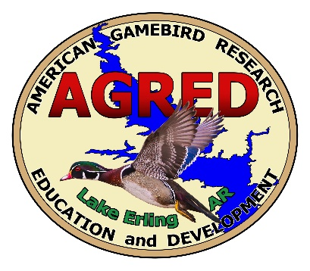

February 2, 2021

Lake Erling Salvinia Cleanout Project (S.C.O.P.)

Although we had not been aware of this new entity, please allow me to commend everyone who has met and is taking a vested interest in eradicating Giant Salvinia on Lake Erling. As most of you know, AGRED Foundation met with various agencies this past week at The AGRED park. A survey was conducted on the lake with a multitude of pictures taken in various areas around the lake.
Communication is key to success. Moving forward, we will make every effort to ensure that those interested are kept in the loop.
As the owner of Lake Erling which is a private lake open to the public, it is essential that we all work together for the same common goal of making Lake Erling the best it can be. Initially my desire was to collect a fee to help maintain the lake and all its beauty. I have no desire to make a profit off of this fee, but to use it for maintenance on the lake. If we all make a concerted effort to work together, then we all win and can enjoy Beautiful Lake Erling and all it has to offer.

Sincerely,

Eric Fletcher
President

